**Project Demo Guidelines**

This assignment is about design and implementation of your project. You have already implemented the complete system in any programming language of your choice. The following need to be provided in this assignment:

1. Demo video explaining the complete software (Screen recording with audio).

**GOOGLE DRIVE LINK OF SHOPPING PORTAL WEBSITE**

<https://drive.google.com/file/d/1qfLhmIzR7fOg0eO5RqqjR6I5x5II_e1b/view?usp=sharing>

**GITHUB LINK**

[**https://github.com/NABEEL-LAB/Softwere-Engineering-all-Assignments**](https://github.com/NABEEL-LAB/Softwere-Engineering-all-Assignments)

1. Software User Instructions Manual explaining how to use your software.

**Summer 2020**

Design of E-Commerce Site for Online Shopping

**GROUP MEMBERS**

**MUHAMMAD SANNAN 12395**

**SYED MAAZ ANWER 9360**

**NABEEL AHMED 13839**

**MIRZA SHAMEER BAIG 10241**

**Design of E-Commerce Site for Online Shopping**

**ABSTRACT**

In today’s fast-changing business environment, it’s extremely important to be able to respond to client needs in the most effective and timely manner. If your customers wish to see your business online and have instant access to your products or services.

Online Shopping is a lifestyle e-commerce web application, which retails various fashion and lifestyle products (Currently Men’s Wear). This project allows viewing various products available enables registered users to purchase desired products instantly using PayPal payment processor (Instant Pay) and also can place order by using Cash on Delivery (Pay Later) option. This project provides an easy access to Administrators and Managers to view orders placed using Pay Later and Instant Pay options.

In order to develop an e-commerce website, a number of Technologies must be studied and understood. These include multi-tiered architecture, server and client side scripting techniques, programming language (such as PHP) and relational databases. This is a project with the objective to develop a basic website where a consumer is provided with a shopping cart application and also to know about the technologies used to develop such an application.

This document will discuss each of the underlying technologies to create and implement an

E-commerce website.

**Design of E-Commerce Site for Online Shopping**

**1.0 INTRODUCTION:**

E-commerce is fast gaining ground as an accepted and used business paradigm. More and more business houses are implementing web sites providing functionality for performing commercial transactions over the web. It is reasonable to say that the process of shopping on the web is becoming commonplace.

The objective of this project is to develop a general purpose e-commerce store where product like clothes can be bought from the comfort of home through the Internet. However, for implementation purposes, this paper will deal with an online shopping for clothes.

An online store is a virtual store on the Internet where customers can browse the catalog and select products of interest. The selected items may be collected in a shopping cart. At checkout time, the items in the shopping cart will be presented as an order. At that time, more information will be needed to complete the transaction. Usually, the customer will be asked to fill or select a billing address, a shipping address, a shipping option, and payment information such as credit card number. An e-mail notification is sent to the customer as soon as the order is placed.

**2.0 OVERALL DESCRIPTION:**

**2.1Description:**

* Any member can register and view available products.
* Only registered member can purchase multiple products regardless of quantity.
* Contact us page is available to contact Admin for queries.
* There are three roles available: Visitor, User and Admin.
  + Visitor can view available products.
  + User can view and purchase products.
  + An Admin has some extra privilege including all privilege of visitor and user.
    - Admin can add products, edit product information and add/remove product.
    - Admin can add user, edit user information and can remove user.
    - Admin can ship order to user based on order placed by sending confirmation mail.

**Design and Implementation of E-Commerce Site for Online Shopping**

**2.2Using the code:**

1. Attach the database in your "SQL Server Management Studio Express".
2. Run the application on Microsoft Visual Studio as web site.
3. Locate the database.

**2.3MasterPage details:**

* Online Shopping

**2.4Web Pages details:**

* Home Page
* Clothing Page
* Order Us Page
* Admin Page
* Login Page
* Register Page
* Track

**Design of E-Commerce Site for Online Shopping**

**3.0 SYSTEM REQUREMENTS:**

**3.1 USE-CASE DIAGRAM:**

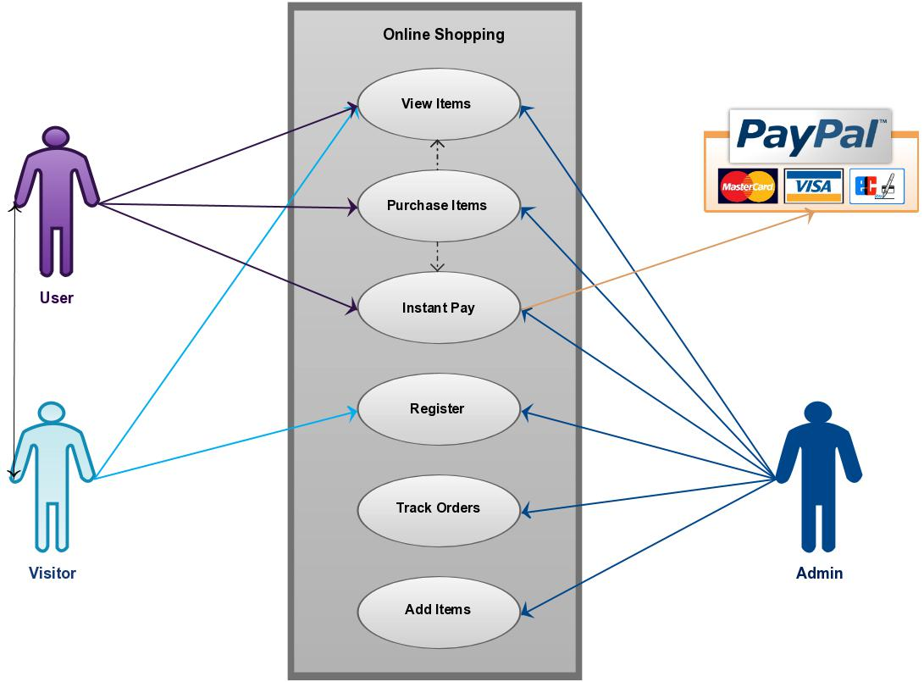

**Design and Implementation of E-Commerce Site for Online Shopping**

**4.0 ONLINE SHOPPING APPLICATION:**

Anyone can view Online Shopping portal and available products, but every user must login by his/her Username and password in order to purchase or order products. Unregistered members can register by navigating to registration page. Only Admin will have access to modify roles, by default developer can only be an ‘Admin’. Once user register site, his default role will be ‘User’.

**4.1 HOMEPAGE:** The Home Screen will consist of screen were one can browse through theproducts which we have on our website

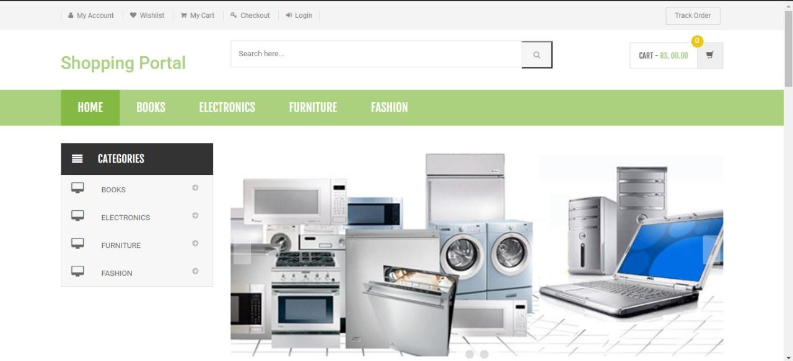

**Design of E-Commerce Site for Online Shopping**

**4.2. FEATURES PRODUCTS:** This page consists of product details. This page appearssame for both visitors and users.

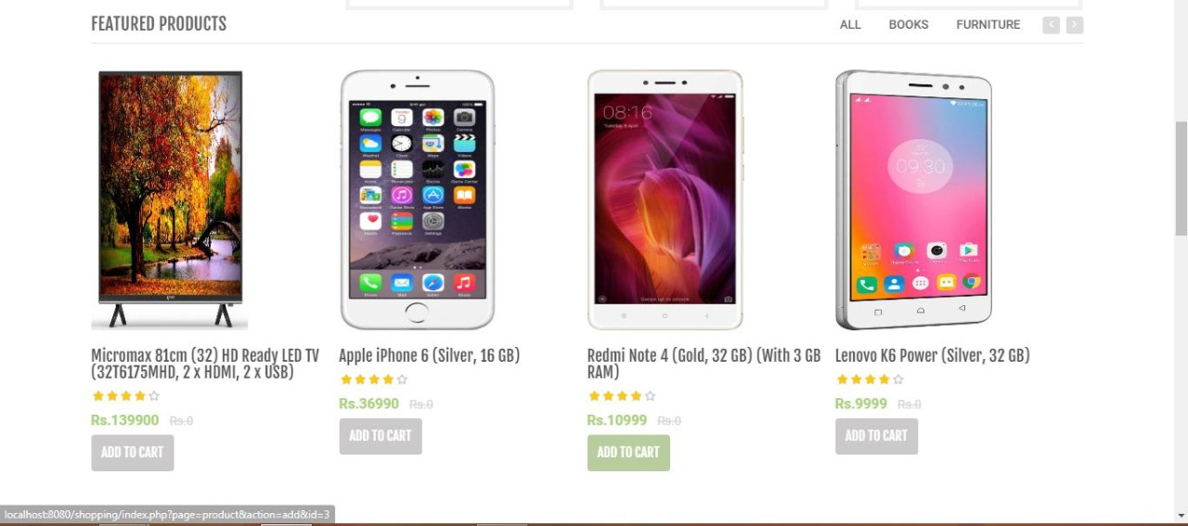

**4.3 Order Us Page:** Registered users can order desired products from here.

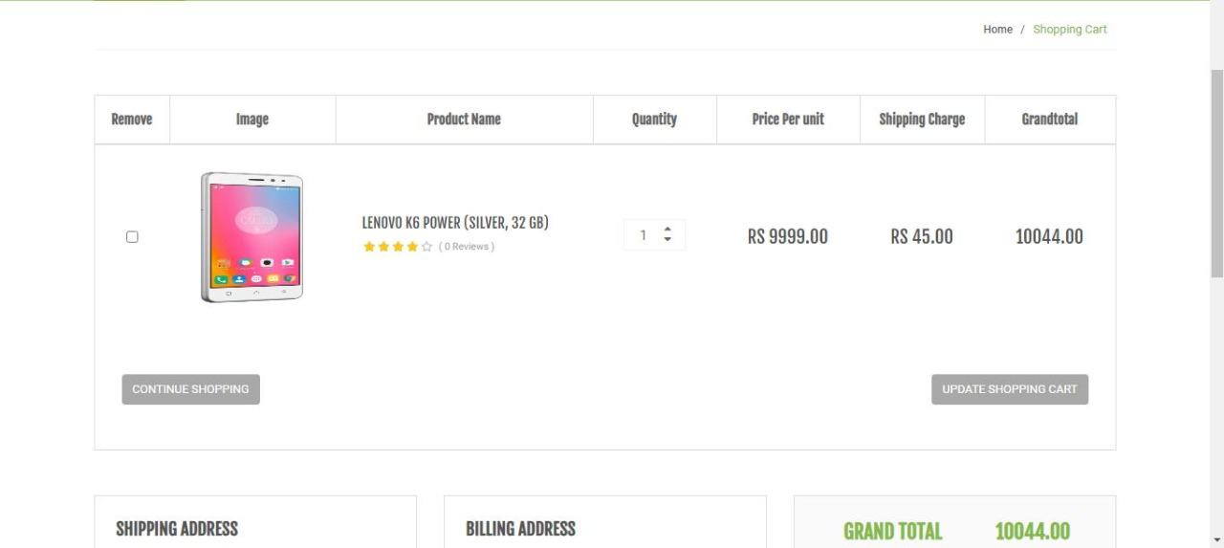

**Design and Implementation of E-Commerce Site for Online Shopping**

**4.4 SIGN IN PAGE:** Sign In page for users

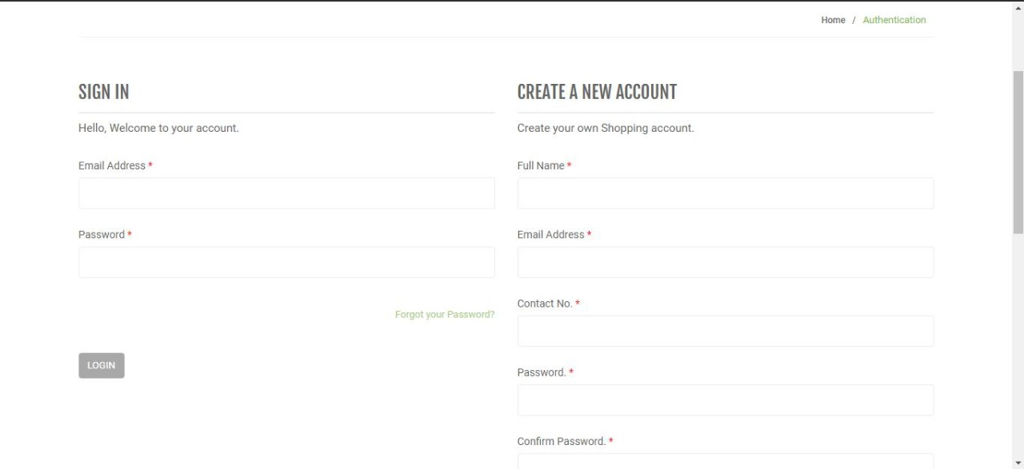

**4.5 Admin Page:** Only difference you see in this page is Role: Admin. User and Admin role willbe checked once the page was login and Session [“role”] will be either Admin or User. If credentials belong to Admin then role will be Admin and if credentials belong to User then role will be User.

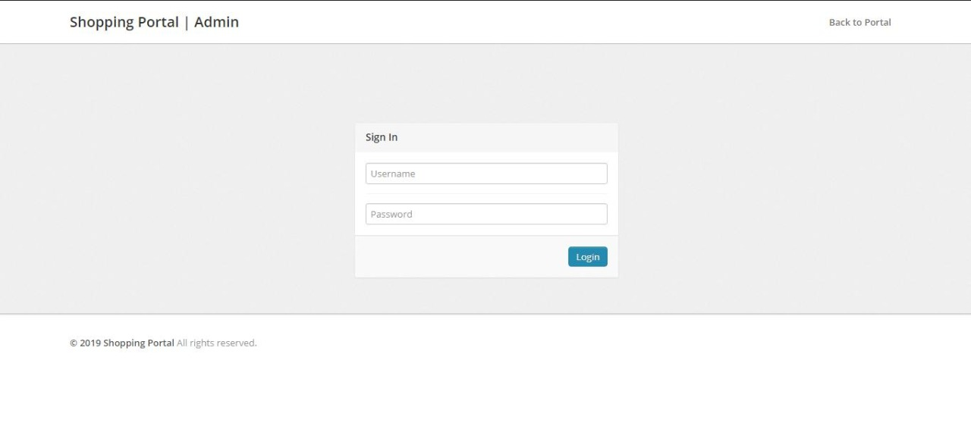

**Design and Implementation of E-Commerce Site for Online Shopping**

**5.0 Non-Functional / Operational Requirements**

**5.1 Security**

* Pages of the website must be access in the way they were intended to be accessed. Included files shall not be accessed outside of their parent file.
* Administrator can only perform administrative task on pages they are privileged to access. Customers will not be allowed to access the administrator pages.

**5.2 Efficiency and Maintainability**

* Page loads should be returned and formatted in a timely fashion depending on the

request being made.

* Administrators will have the ability to edit the aspects of the order forms, product descriptions, prices and website directly

**6.0 Conclusion:**

The Internet has become a major resource in modern business, thus electronic shopping has gained significance not only from the entrepreneur’s but also from the customer’s point of view. For the entrepreneur, electronic shopping generates new business opportunities and for the customer, it makes comparative shopping possible.

As per a survey, most consumers of online stores are impulsive and usually make a decision to stay on a site within the first few seconds. “Website design is like a shop interior. If the shop looks poor or like hundreds of other shops the customer is most likely to skip to the other site. Hence we have designed the project to provide the user with easy navigation, retrieval of data and necessary feedback as much as possible. In this project, the user is provided with an e-commerce web site that can be used to buy books online. To implement this as a web application we used PHP as the Technology. PHP has several advantages such as enhanced performance, scalability, built-in security and simplicity.

1. Complete System and program design (as discuss in lecture) of your project.

**SYSTEM DESGIN**

Web Customer actor uses a few web location to create buys online. Best level use cases are View Items, Make Purchase and Client Register. View Items case may well by client as best level case in the event that client as it were needs to discover and see a few items. This case may too bed as a portion of Make Purchase case. Client Register use case permits client to enlist on the net location, for illustration to induce a few coupons or be welcomed to private deals. Note, that Checkout use case is included case not accessible by itself checkout is portion of making purchase. Except for the Web Customer actor there are a few other performing artists which

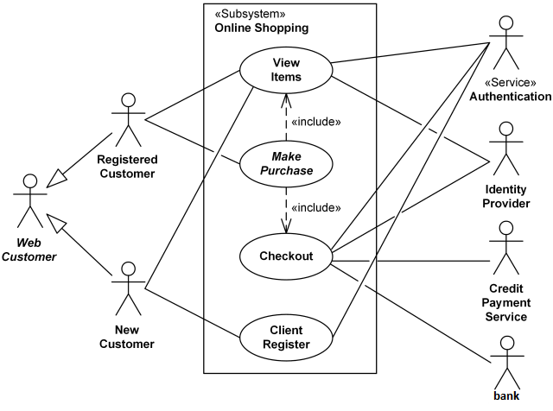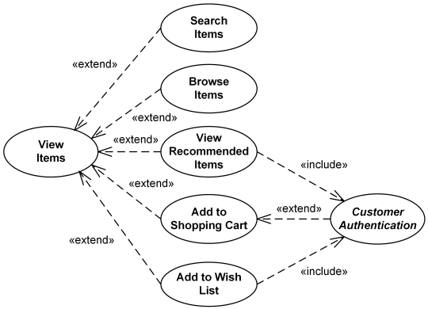

Can be depicted underneath with point by point cases. View Items use case is [extended](https://www.uml-diagrams.org/use-case-extend.html) by several optional use cases - customer may search for items, browse catalog, view items recommended for him/her, add items to shopping cart or wish list. All these use cases are extending use cases because they provide some optional functions allowing customer to find item.

Customer Authentication use case is [included](https://www.uml-diagrams.org/use-case-include.html) in View Recommended Items and Add to Wish List because both require the customer to be authenticated. At the same time, item could be added to the shopping cart without user authentication.

**PROGRAM DESIGN**

**UML OF PROGRAM DESIGN**

